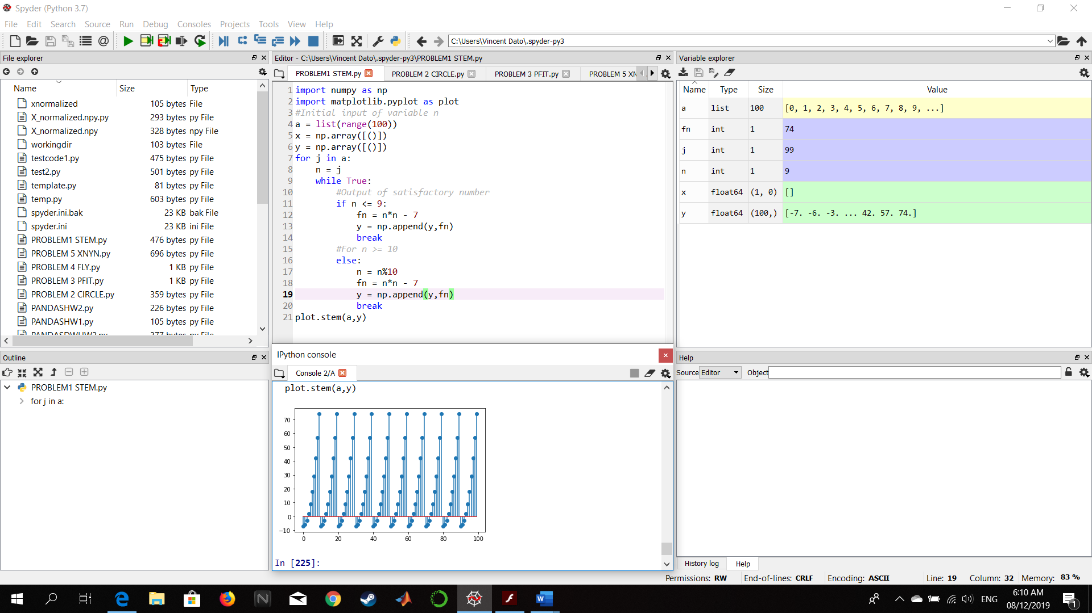PROBLEM 1 – PYTHON

Figure : Screenshot of Code and Output

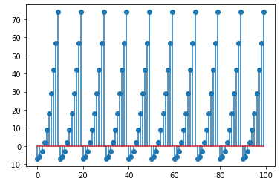

Figure : Plot Output

DISCUSSION:

The plot of f(n) is similar to a bar graph due to the code used, stem(), unlike other plots with the code plot() that results in a curve.